
RAMAIAH
INSTITUTE OF TECHNOLOGY
USN | 1 | M | S

(Autonomous Institute, Affiliated to VTU)
Bangalore – 560 054

SEMESTER END EXAMINATIONS – MAY/JUNE 2017

Course & Branch | : | B.E. : Common to CSE / ISE | Semester | : | IV
Subject | : | Engineering Mathematics - IV | Max. Marks | : | 100
Subject Code | : | CS/IS MAT41 | Duration | : | 3 Hrs

Instructions to the Candidates:
- Answer one full question from each unit.

 |  | UNIT-I
1. | a) | Find the first order divided difference of 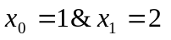if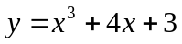 | CO1 | (02)
 | b) | Derive the formula to find 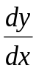 using Newton’s forward interpolation formula. | CO1 | (03)
 | c) | A solid of revolution is formed by rotating about the x-axis, the area between the x-axis, the lines x=0 and x=1 and a curve through the points with the following co-ordinates  Estimate the volume of the solid formed using Simpson’s (1/3)^{rd} rule. | CO1 | (08)
  x | 0.00 | 0.25 | 050 | 0.75 | 1.00
  y | 1.0000 | 0.9896 | 0.9589 | 0.9089 | 0.8415
 | d) | Given the following data find f(9) using Newton’s divided difference formula. | CO1 | (07)
  x | 5 | 7 | 11 | 13 | 17
  f(x) | 150 | 392 | 1452 | 2366 | 5202
2. | a) | Write the formula to solve f(x)=0 for the set of points (x₁,y₁)(x₂,y₂) | CO1 | (02)
 | b) | Solve by 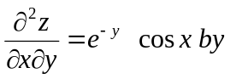Direct Integration method. | CO1 | (03)
 | c) | Solve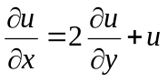, given that by method of separation of variables | CO1 | (08)
 | d) | Find the maximum and minimum values of the function y = f(x) from the following data. | CO1 | (07)
  x | 1 | 3 | 5 | 7 | 9
  y | 9 | 11 | 13 | 63 | 209
 |  | UNIT-II
3. | a) | Define Mathematical expectation of the function φ(X) of the random variate X in both discrete and continuous cases. | CO2 | (02)
 | b) | For the Normal distribution with mean μ and standard deviation σ evaluate P(|x-μ|<2σ). | CO2 | (03)
 | c) | The pdf of a random variable X is given by 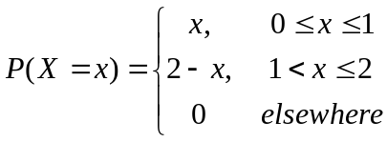  Find (i) Cumulative distribution function F(X)  (ii) P(X ≥ 1.5). | CO2 | (08)
 | d) | If a random variable k is uniformly distributed over (0, 5), what is the probability that the roots of the equation 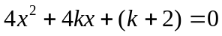 are real. | CO2 | (07)
4. | a) | Write pdf of Binomial distribution. | CO2 | (02)
 | b) | A random variable 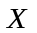 is uniformly distributed over the interval (-2,2). Find (i) 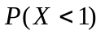 (ii) 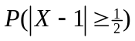 | CO2 | (03)
 | c) | In a normal distribution 10% are under 40 and 80% are under 65. Find the mean and standard deviation of the normal distribution. | CO2 | (08)
 | d) | The sales per day in a shop are exponentially distributed with average sale amounting to Rs.100 and net profit is 8%. Find the probability that the net profit exceeds Rs.30 atleast on two days in seven consecutive days. | CO2 | (07)
 |  | UNIT-III
5. | a) | Define marginal probability distribution of X and Y | CO3 | (02)
 | b) | The joint probability density function of X and Y is given by  Find the value of k. | CO3 | (03)
 | c) | Show that 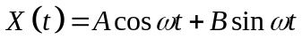 where A and B are uncorrelated random variables each with mean 0 and variance 1 and ω is a positive constant is a WSS. | CO3 | (08)
 | d) | The joint distribution of two variables X and Y are given below  Evaluate the following:  (i) E(X) and E(Y) (ii) E(XY) (iii) 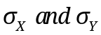  (iv) COV(X,Y) (v) 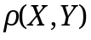 | CO3 | (07)
  Y  X | -2 | -1 | 4 | 5
  1 | 0.1 | 0.2 | 0 | 0.3
  2 | 0.2 | 0.1 | 0.1 | 0
6. | a) | Define Ergodicity. | CO3 | (02)
 | b) | Classify the stochastic process. | CO3 | (03)
 | c) | A fair coin is tossed three times. Let X denote 0 or 1 according as the head or tail occurs on the first toss. Let Y denote the number of heads which occur. (i) Find the marginal distributions of X and Y, (ii) determine the joint distribution of X and Y and (iii) Cov(X,Y). | CO3 | (08)
 | d) | Suppose that the joint density function of two continuous random variables x and y is 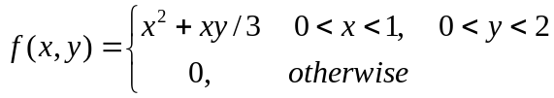  Find 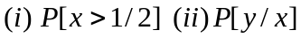 | CO3 | (07)
 |  | UNIT-IV
7. | a) | Define M/M/1 and M/G/1 queuing systems | CO4 | (02)
 | b) | A student’s study habits are as follows. If he studies one night, he is 70% sure not to study the next night. On the other hand, if he does not study one night, he is 60% sure not to study the next night as well. In the long run, how often does he study? | CO4 | (03)
 | c) | At a one man barber shop, it takes on the average half an hour for a hair cut and customers arrive at an average rate of one per every 45 minutes, If the Poisson Exponential model is assumed, at any point in time, on the average  - How many customers will there be in the shop?  - What time will a customer spend in the shop?  - Of this time, what part be spent waiting to be served?  - What portion of the day will barber be idle? | CO4 | (08)
 | d) | Automatic car wash facility operates with only one boy. Car arrive according to a Poisson distribution, with a mean of 4 cars per hour and may wait in the facility’s parking lot if the boy is busy. If the service time for all cars is constant and equal to 10 minutes determine E(m), E(n), E(T) and E(w). | CO4 | (07)
8. | a) | Define M/M/1 and M/G/1 queuing systems | CO4 | (02)
 | b) | Define the terms  (i) Periodic state (ii) Absorbing state (iii) Recurring state. | CO4 | (03)
 | c) | Patients arrive at a clinic according to a Poisson distribution at a rate of 30 patients per hour. The waiting room does not accommodate more than 14 patients. Examination time per patient is exponentially with mean rate 20 per hour  i) Find the effective arrival rate at the clinic.  ii) What is the probability that an arriving patient will not wait?  iii) What is the expected time until a patient is discharged from the clinic? | CO4 | (08)
 | d) |  | CO4 | (07)
  There are 2 white marbles in bag A and 3 red marbles in bag B.
  At each step of the process a marble is selected at random
  from each bag and the two marbles selected are interchanged
  then find (i) transition probability matrix (ii) what is the
  probability that there are 2 red marbles in A after 3 steps
  (iii) In the long run what is the probability that there are 2 red
  marbles in A?
 |  | UNIT-V
9. | a) | State the condition when F test is used | CO5 | (02)
 | b) | Define null hypothesis and alternate hypothesis. | CO5 | (03)
 | c) | The following table shows the result of an experiment to investigate the effect of vaccination induced on the animals against a particular disease. Use the χ² test to test the hypothesis that there is no difference between and vaccinated and unvaccinated groups i.e. vaccination and this disease are independent | CO5 | (08)
   | Got disease | Did not get disease
  vaccinated | 9 | 42
  Not vaccinated | 17 | 28
 | d) | Eleven school boys were given as test in drawing. They were given a month’s further tuition and a second Test at of equal difficulty was held at the end of it. Do the marks give evidence that the students have benefited by extra coaching. | CO5 | (07)
  Boys | 1 | 2 | 3 | 4 | 5 | 6 | 7 | 8 | 9 | 10 | 11
  Marks I test | 23 | 20 | 19 | 21 | 18 | 20 | 18 | 17 | 23 | 16 | 19
  Marks II test | 24 | 19 | 22 | 18 | 20 | 22 | 20 | 20 | 23 | 20 | 17
10. | a) | Define confidence interval. | CO5 | (02)
 | b) | A machinist is making engine parts with axle diameter of 0.7 inch. A random sample of 10 parts shows mean diameter 0.742 inch with a SD of 0.04inch .On the basis of the sample, would you say that the work is inferior? | CO5 | (03)
 | c) | The following tables gives the number of train accidents in a country that occurred during the various days of the week. Find whether the accidents are uniformly distributed over the week. | CO5 | (08)
  Days | Sun | Mon | Tues | Wed | Thu | Fri | Sat
  No. of accidents | 20 | 18 | 13 | 23 | 26 | 11 | 15
 | d) | Fit a Poisson distribution for the following data and test the goodness of fit. | CO5 | (07)
  x: | 0 | 1 | 2 | 3 | 4 | 5 | 6 | Total
  f: | 273 | 70 | 30 | 7 | 7 | 2 | 1 | 390

****************

